**FOR QEV  
Prepare mef3 manually**

**To upload mef3**

on command prompt

go to the directory where mef3 file is then

cd <file path>

then  
ftp congsa.ibm.com

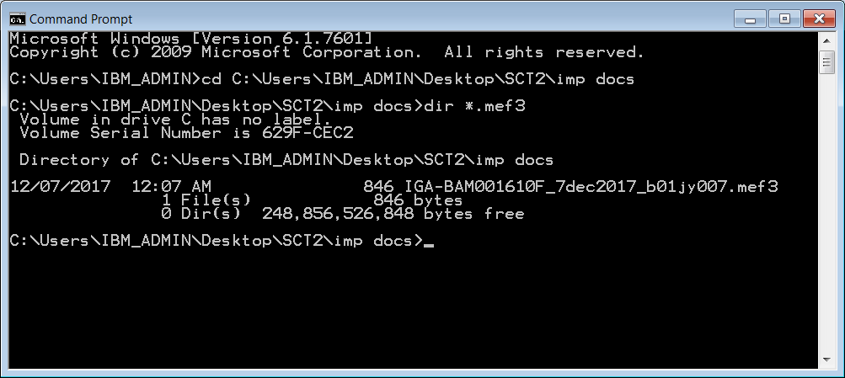

Type anonymous and press enter

Type intranet email id when asked for password

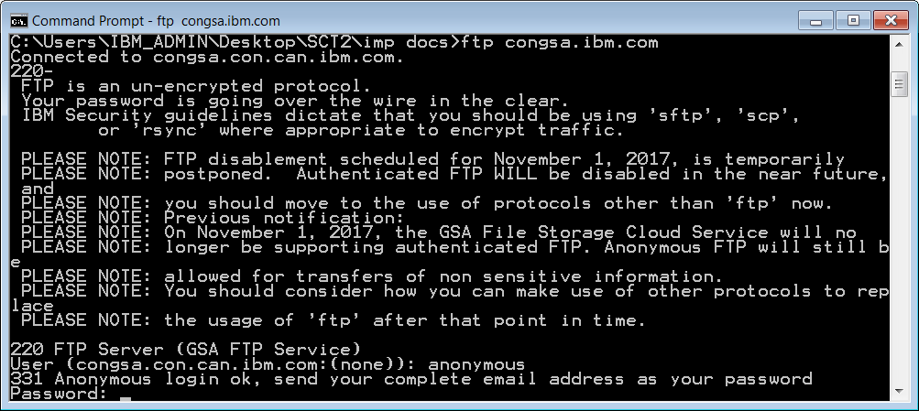

Type ***cd projects/u/urt_ag***

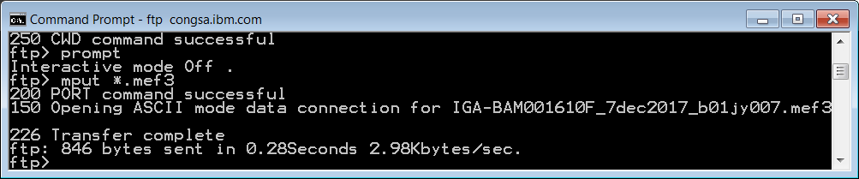

Wait for 15 min and then go to URT URL  
<https://bldsarmurtprd02.extnet.ibm.com/tools/id/ag/controller?action=customers>

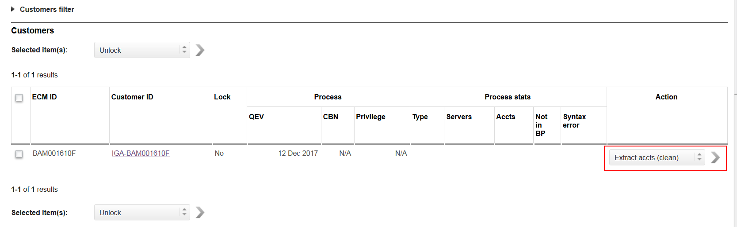

Then

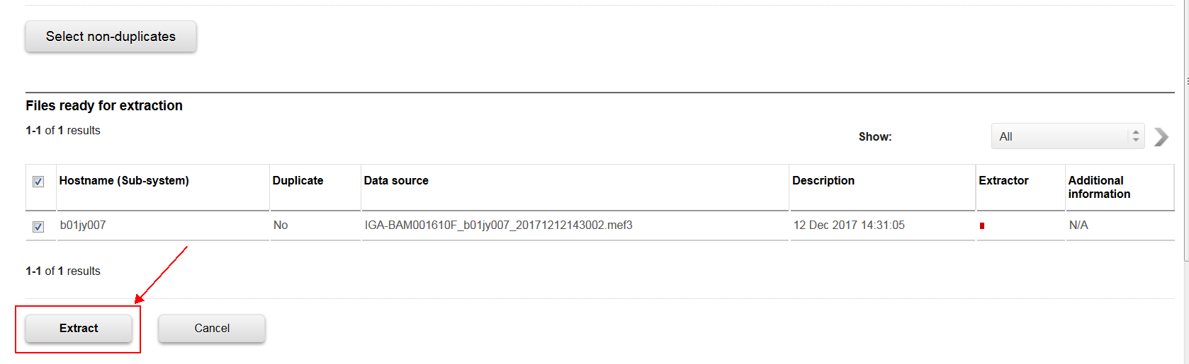

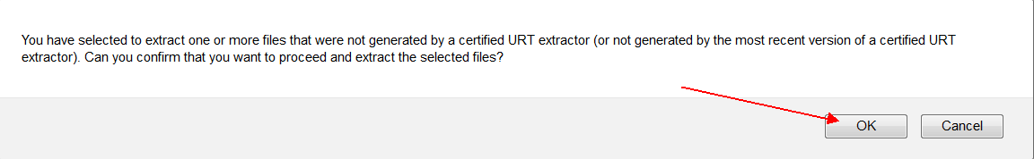

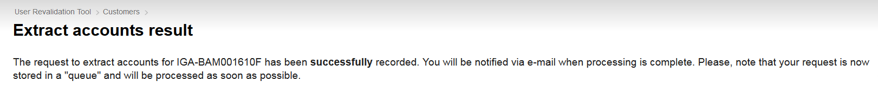

Wait for an email of the extract completion

Go for Simple QA

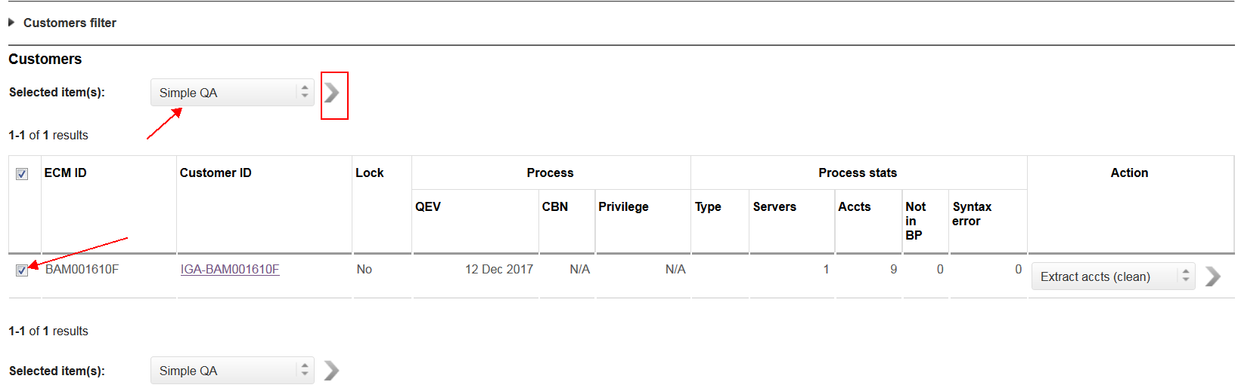

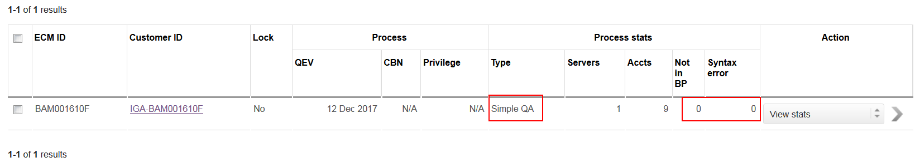

Wait for mail confirmation

Once got the confirmation mail go for PO assignments

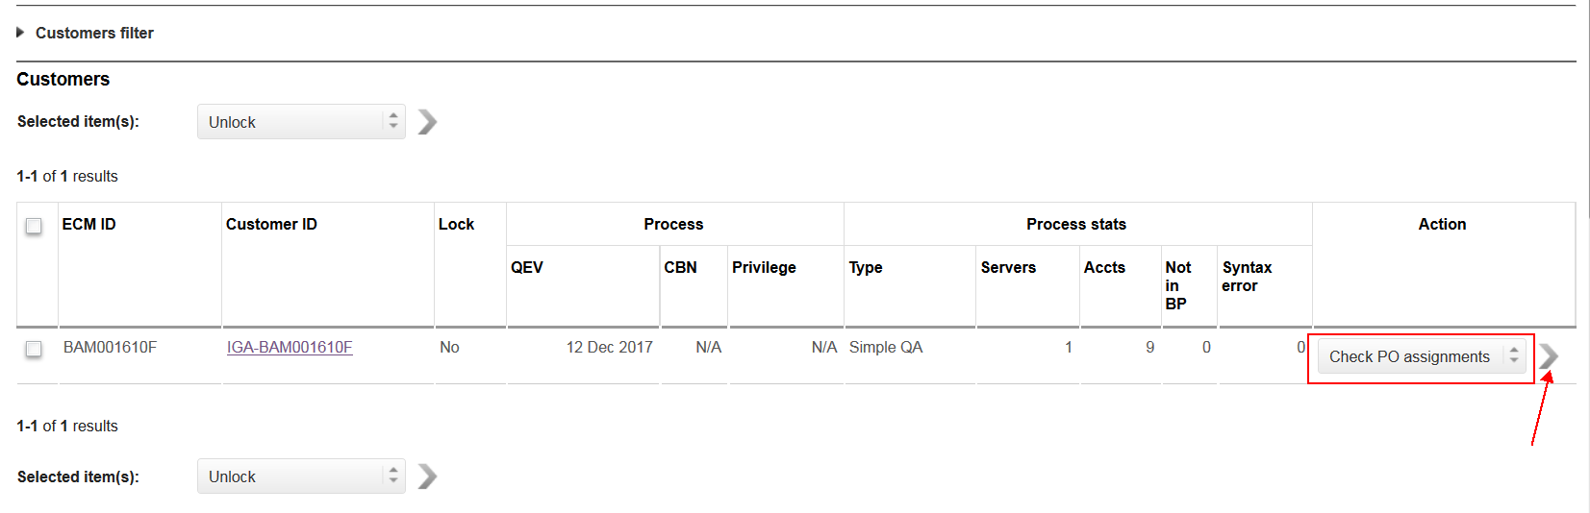

After clicking the next you will get result like this

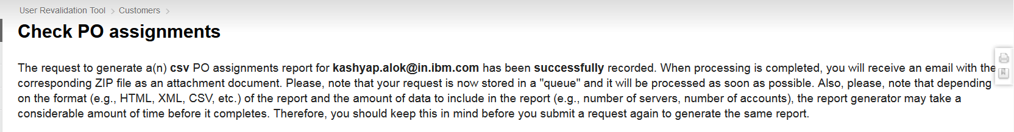

Wait for mail with attachment

If attachement is there we have to work on privilege owner configurations

If no attachment in mail then go for privilege

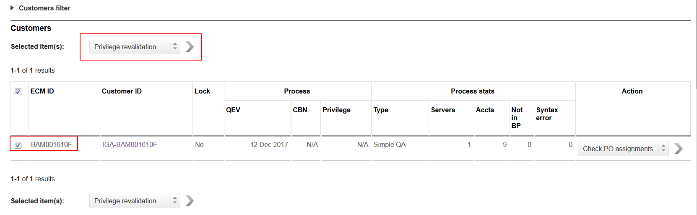

For the popup

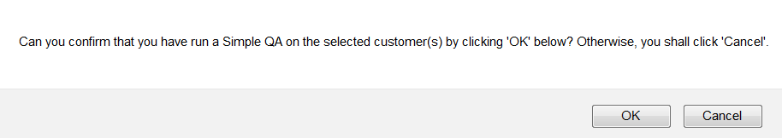

Press Ok

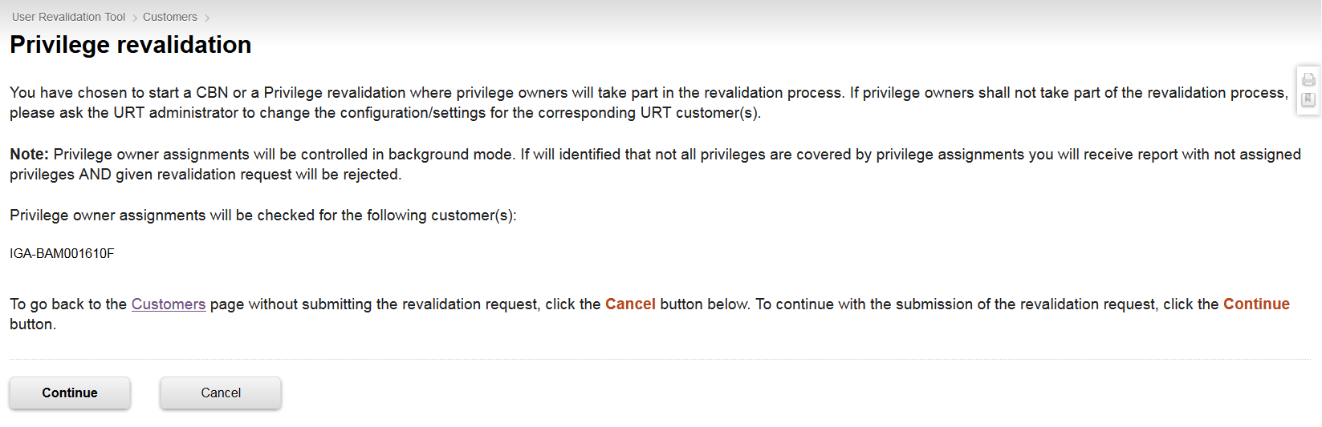

Press Continue

